BlackBerry mOcean SDK

Developer Guide

Version 2.11

Table of Contents

Table of Contents 2

What’s new in 2.10 3

How to move from previous version to 2.10 4

System Requirements 4

Feature list 4

Installing the Ad SDK 5

Add the Latest version of SDK library project to your app 5

Use case MASTAdView 7

Simple ad integration 7

Interstitial ad integration 8

Customize MASTAdView 10

Customize view appearance. 10

Customize Interstitial ad 11

Customize view appearance. 11

Customize Ad Updates 11

# What’s new in 2.11

* Dma attribute of MASTAdview is obsolete, use the new Metro attribute instead for future compatibility (metho setMetro()).
* If (max) size X or Y parameter is set to something less than the minimum X or Y value, send the minimum in the request to the server.
* Device location detection now OFF by default, so latitude and longitude are NOT included in the request to the server.
* New attribute to control location detection, via method setLocationDetection(), can be set to true to turn on location detection.
* New attribute to control frequency of ongoing location updates so that a position update will occur no more than a certain number of milliseconds. Use the setLocationMinWaitMillis() method. Default value is 5 minutes (5 * 60 * 1000 milliseconds.)
* Ignore content, if server returned response code != 200, but follow up 30x redirection
* The sample applications were updated
* Ad request timeout changed from 1 second (1000 millis) to 3 seconds (3000 millis.)

# How to move from previous version to 2.11

1. If you use the Metro attribute, change to the new Dma attribute.
2. If you use location detection on device, enable location detection in your app by calling the setLocationDetection(true) method.

# System Requirements

* Microsoft Windows XP or later.
* IDE, supports BlackBerry environment:

Eclipse (http://us.blackberry.com/developers/javaappdev/javaplugin.jsp)

Netbeans (http://netbeans.org/downloads/index.html) with Blackberry plugin (http://plugins.netbeans.org/PluginPortal/faces/PluginDetailPage.jsp?pluginid=11194 )

BlackBerry JDE (http://us.blackberry.com/developers/javaappdev/javadevenv.jsp )

# Feature list

* **HTML/ JS ads** (java script limited to BrowserField2 capabilities)

SDK supports displaying web ads using BrowserField2 component.

* **Location auto detect**

SDK could automatically detect user location

* **User-Agent auto detect**

SDK automatically detects device User-Agent

* **Ad visibility tracking**

SDK automatically disable ads updates on visibility ad hiding.

* **Logging**

SDK supports logging.

# Installing the Ad SDK

## Add the Latest version of SDK library project to your app

1. Add the MASTAdview.jar file into library folder.

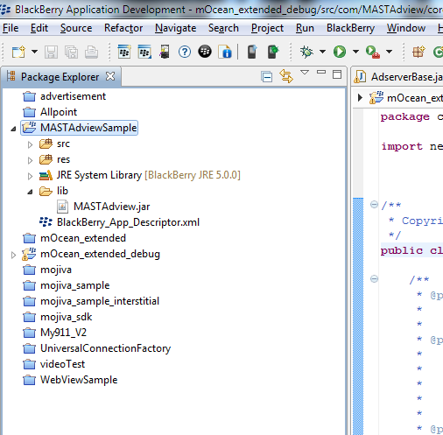

## 

1. Add mOcean SDK jar into project build path

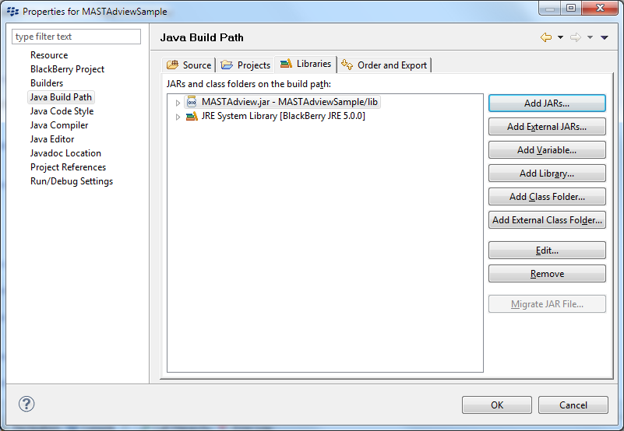

1. Open “Order and Export” tab and select MASTAdview.jar

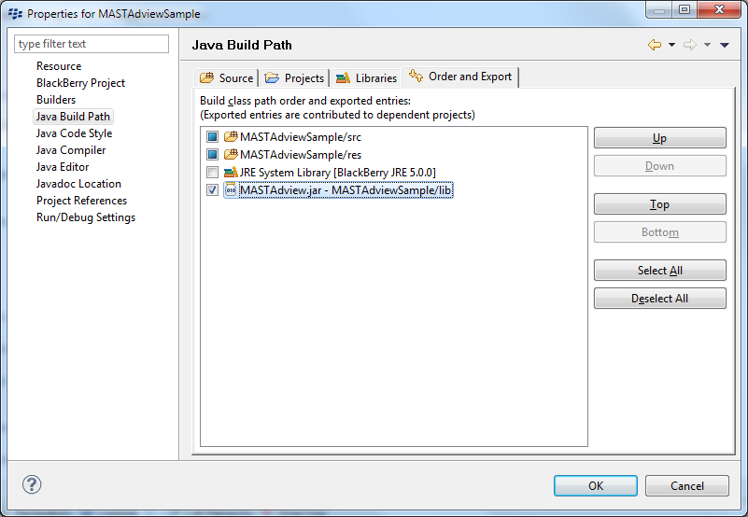

# Use case MASTAdView

1. A simple banner that is used for the embedding of the existing form and occupies a small area in it.
2. Interstitial is used for the full screen banner display. It’s displayed only once and after closing it becomes inactive.

# Simple ad integration

To add MASTAdView into your application just import com.MASTAdview.core.MASTAdview class

import com.MASTAdview.core.MASTAdview;

put initialize code

MASTAdview field = **new** MASTAdview(19829, 88269);

field.setSize(360, 50);

field.setUpdateTime(20);

field.setLoggerId("AdLogger1");

and add field to screen

add(field);

For more code samples examine Samples application

If there are several banners of different sizes in the same Zone, this can be useful for the targeting of the different devices, but it’s necessary to determine, the proper size of the banner for each device. For the determination of the size, please use the following parameters minSize and maxSize.

field.setMinSizeX(320);

field.setMinSizeY(50);

To determine correct banner for portrait and landscaperedefine sublayout for current screen :

public void sublayout(int width, int height)

{

if(Display.getOrientation()== Display.ORIENTATION_LANDSCAPE)

{

field.setSite(8061);

field.setZone(16741);

int displayWidth = Display.getWidth();

field.setSize(displayWidth, 50);

field.update();

}

else if(Display.getOrientation()== Display.ORIENTATION_PORTRAIT)

{

field.setSite(8061);

field.setZone(20249);

int displayWidth = Display.getWidth();

field.setSize(displayWidth, 50);

field.update();

}

super.sublayout(width, height);

}

For complete example please see AdvancedAdOrientationScreen sample.

# Interstitial ad integration

To add interstitial ad into your application just import

import com.MASTAdview.core.MASTAdview;

And put initialize code:

MASTAdview interstitialControl = new MASTAdview(8061, 16112);

interstitialControl.setMinSizeX(320);

interstitialControl.setMinSizeY(460);

interstitialControl.setUpdateTime(5);

interstitialControl.setSize(320, 460);

and run show() method:

interstitialControl.show();

See Also:

* For more code samples examine AdMobileSamples application.

# Customize MASTAdView

## Customize view appearance.

1. Also you can set defaultImage, autoCollapse and showPreviousAdOnError properties that determine what you want to when the error of ad update. Note by default MASTAdView is always visible.

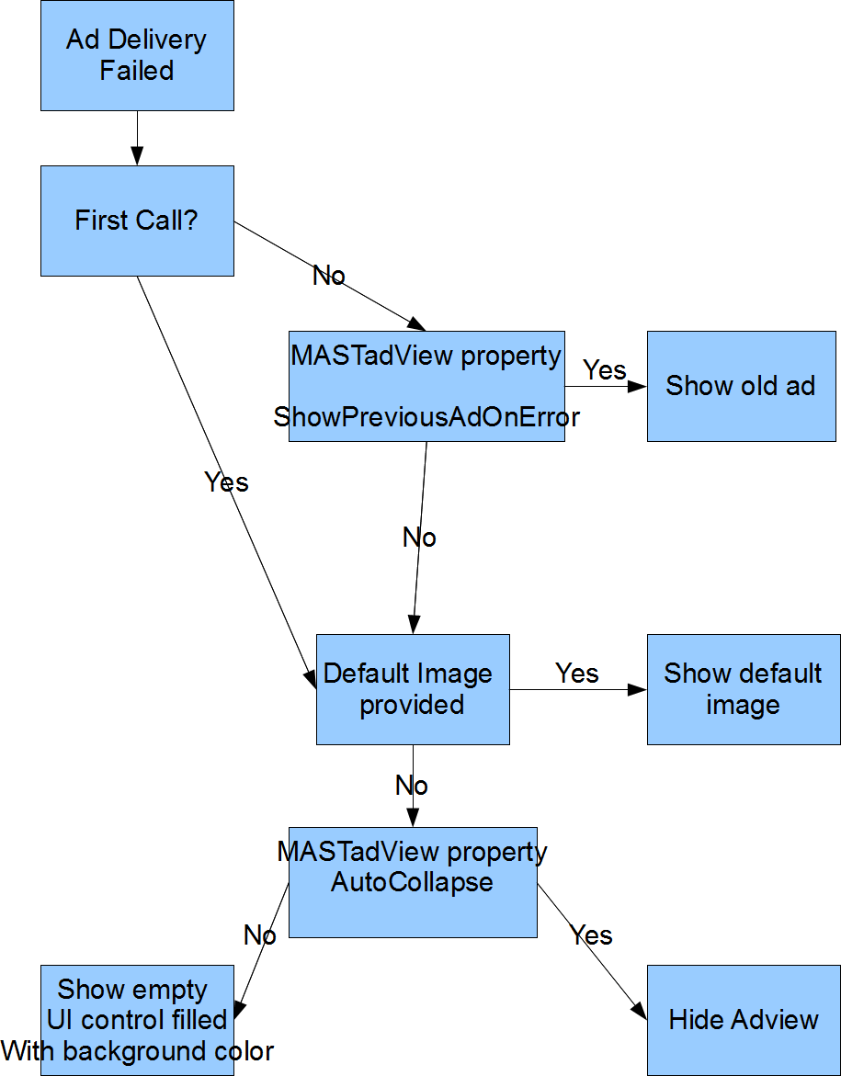

Note: defaultImage property doesn’t work properly at 2.10 version

3. Set contentAlignment property to enable auto alignment content in center vertically and horizontally.

# Customize Interstitial ad

## Customize view appearance.

1. To enable auto close interstitial timer - set time interval autoCloseInterstitial property, in seconds.

2. You can delay close button that is displayed by setting showCloseButtonTime property up.

# Customize Ad Updates

SDK updates content by following events:

1. update Timer used (by default is 120 sec). This is the interval between finishing of the previous download and starting a new one.
2. by “update” method. Useful to preload content or change content on Rotate.